SD CARD INTERFACE USING FPGA FOR MULTIMEDIA APPLICATIONS

A PROJECT REPORT

Submitted by
SAKTHEKANNAN M S | 212220060228
UDAYA KRISHNAN M | 212219060284
YOGAVIGNES B M | 212219060302

In partial fulfilment for the award of the degree

of

BACHELOR OF ENGINEERING

in

ELECTRONICS & COMMUNICATION ENGINEERING


SAVEETHA ENGINEERING COLLEGE, KANCHEEPURAM

ANNA UNIVERSITY

CHENNAI 600 025

DECEMBER – 2022
SAVEETHA ENGINEERING COLLEGE (AUTONOMOUS), CHENNAI
ANNA UNIVERSITY, CHENNAI – 600 025
BONAFIDE CERTIFICATE

Certified that this Report titled “SD CARD INTERFACE USING FPGA FOR MULTIMEDIA APPLICATIONS” is the bona-fide work of “SAKHTEKANNAN M S (212219060228), UDAYA KRISHNAN M (212219060284), YOGAVIGNES B M (212219060302)” who carried out the work under my supervision.

SIGNATURE SIGNATURE
Dr. SRIGITHA S NATH, M.E., Ph.D Dr. NAVANEETHAN S, M.E.,Ph.D
HEAD OF THE DEPARTMENT SUPERVISOR
Professor Assistant Professor
Department of ECE, Department of ECE,
Saveetha Engineering College, Saveetha Engineering College,
Thandalam, Thandalam,
Chennai - 602105 Chennai – 602105

Submitted for the project viva-voce examination held on ________________.

INTERNAL EXAMINER EXTERNAL EXAMINER

ACKNOWLEDGEMENT

If words were considered as symbols of approval and token of acknowledgement, then let words play the heralding role of not praising and glorification but also to exhibit the deeply embedded feelings of thanks and gratefulness.

We wish to express our gratitude to our Founder president, Dr. N.M. Veeraiyan, President Dr. V. Saveetha and Director Dr. S. Rajesh and for providing us with the facilities for the completion of our project. We also thank our principal Dr.N.Duraipandian , M.E.Ph.D., for his continuous support and encouragement in carrying out our project work. Also, our thanks to Dr. Srigitha S Nath M.E., Ph.D., Head of the Department, Electronics and Communication Engineering of our college for providing us facilities and permission to carry out our project work

We mention our special thanks to our project coordinator Dr. S. Navaneethan M.E., Ph.D., Assistant Professor, Department of Electronics and Communication Engineering for his wisdom, guidance, and constant encouragement. We manifest cut deep sense of gratitude to our internal guide Dr. Srigitha S Nath M.E, Ph.D., Assistant professor, Department of Electronics and Communication Engineering for his encouragement and faith in as though this endeavor.

We take this opportunity to acknowledge the efforts to staff members and friends at Saveetha Engineering College for their sincere cooperation in guiding us. Finally, we express our deepest gratitude to our family, for their constant encouragement, support and motivation throughout under graduate career and for always being there for us.

TABLE OF CONTENTS
CHAPTER NO. TITLE PAGE NO.
ABSTRACT iii
LIST OF FIGURES iv
LIST OF ABBREVIATIONS v
LIST OF TABLES vi
- INTRODUCTION 1
- LITERATURE SURVEY 2
- SD CARD 4
3.1 SD CARD PRINCIPLE 4
3.2 MODE OF TRANSMISSION 4
3.3 BUS PROTOCOL OF SD CARD 6
3.4 SYSTEM FILE OF SD CARD 6
3.5 SD CARD COMMANDS 6
4. FPGA 8
4.1 FPGA PRINCIPLE 8
4.2 FEATURES OF FPGA 9
5. SPI 10
5.1 WORKING OF SPI 10
5.2 SERIAL VS PARALLEL COMMUNICATION 11
5.3 PIN FUNCTIONS OF SPI 12
5.4 MISO AND MOSI 12
5.5 SPI DATA TRANSMISSION 12
6. WORKING SYSTEM 14
6.1 REQUIREMENTS 14
6.1.1 SOFTWARE REQUIREMENTS 14
6.1.2 HARDWARE REQUIRMENTS 14
6.2 TYPES OF SD MODES 14
6.3 CONTROL STRUCTURE OF FPGA 15
6.4 SD CARD INITIALIZATION 16
6.5 WRITE DATA FOR SD CARD 17
6.6 READ DATA FOR SD CARD 19
6.7 SD CARD CONTROLLER WORKING 21
6.8 FILE FORMAT OF FAT32 22
6.9 READING FILES FROM FAT32 22
7. RESULTS 25
8. CONCLUSION 26
8.1 FUTURE SCOPE 26
9. REFERENCES 27

ABSTRACT

Based on FPGA (Field Programming Gate Array) chips, this application is used for audio, video and image processing. At the same time, applications require more memory in addition to on-chip memory to resolve additional data. Onboard memory can be used to meet the requirements of FPGA systems but cannot be expanded by adding just a few cards. More convenient is SD card (Secure Digitals) is a microcontroller which can read and write to SD card. The main goal is to provide a storage solution for FPGA, a low-cost, removable, non-volatile, flash memory, portable and easy-to-use storage solution for FPGA for storing large files. The hardware design is done in Verilog HDL language and implemented in FPGA. All data access from the SD card is through Verilog, eliminating the need for an on-chip microcontroller or general-purpose processor. Spartan 6 (XC6SLX9-3csg324) FPGA is used. The FPGA runs on 5V power supply with a built-in oscillator frequency of 100 MHz. A 4GB micro SDHC card (class 6) from Strontium is used in this particular project. FAT32 is formatted by SD card. The ultimate aim of this project is to read a BMP image file from the SD card. FAT32 is formatted by SD card before interfacing. The code for the FAT32 is written to interface the SD card.

LIST OF FIGURES
FIGURE NO | NAME OF THE FIGURE | PAGE NO
1 | BLOCK DIAGRAM OF SD CARD | 3
2 | SD CARD MEMORY ARCHITECTURE | 5
3 | FPGA DEVELOPMENT BOARD | 9
4 | MOSI | 10
5 | BIT TRANSMISSION IN PARALLEL COMMUNICATION | 11
6 | BIT TRANSMISSION IN SERIAL COMMUNICATION | 11
7 | CLOCK SIGNAL | 12
8 | SLAVE SELECT ACTIVATION | 13
9 | MASTER TO SLAVE DATA TRANSFER | 13
10 | SLAVE TO MASTER DATA TRANSFER |  | 13
11 | SPI MODE PIN DIAGRAM | 14
12 | ONE BIT SD PIN DIAGRAM | 14
13 | FOUR BIT SD PIN DIAGRAM | 14
14 | FPGA BLOCK DIAGRAM FOR 4-BIT SD MODE | 15
15 | SD CARD INITIALIZATION | 17
16 | WRITE DATA FLOW CHART | 19
17 | READ DATA FLOW CHART | 20
18 | FORMAT OF FAT32 | 22
19 | FAT32 ALGORITHM FOR READ | 23
20 | READ SCRAMBLER FILE IN MEMORY CORE |  | 24

TABLE NO | NAME OF THE TABLE | PAGE NO
1 | PIN FUNCTIONS OF SD CARD | 6
2 | COMMANDS OF SD CARD FOR SPI MODE | 7
3 | COMPARISON OF 1-BIT SD MODE, 4-BIT SD MODE, SPI MODE | 15
4 | COMPARISON BETWEEN EXISTING METHOD AND OUR METHOD | 25

LIST OF SYMBOLS AND ABBREIVATIONS

LUT | - | Look Up Table
SD | - | Secure Digitals
CLK | - | Clock
CMD | - | Command
FIFO | - | First In First Out
SPI | - | Serial Peripheral Interface
I2C | - | Inter-Integrated Circuit
UART | - | Universal Asynchronous Receiver-Transmitter
USB | - | Universal Serial Bus
WI-FI | - | Wireless Fidelity
DDR | - | Double Data Rate
VGA | - | Video Graphics Array
CPU | - | Central Processing Unit
PCB | - | Printed Circuit Board
OTP | - | One Time Programmable
DSP - |  | Digital Signal Processing

CHAPTER 1

INTRODUCTION

Secure Digital (SD) cards are proprietary non-volatile cards. New generation semiconductor-based memory card an electronic device designed primarily for data storage portable or fixed application. Main advantages of SD cards are small, have large storage capacities and fast data bits, price, high energy efficiency, great flexibility, excellent safety. I have an SD card along with a USB memory stick portable storage device most commonly used in digital systems about microprocessors, microcontrollers and Digital Signals Processor (DSP) or Field Programmable Gate Array in various applications such as (FPGA) chips, digital cameras, laptops, mobile phones, embedded systems.
SD cards (Secure Digital Memory Cards) are flash memory chips based on new generation semiconductors storage device. Large capacity SD card, high speed data transfer speeds, great flexibility, great mobile security. Considering system size, performance, and storage capacity, it's easy to see that opting for an SD card offers great benefits as a storage device for systems based on FPGA chip.

CHAPTER 2
LITERATURE SURVEY

According to Dumitrel Catalin Costach [1] an FPGA controller reads and writes to an SD card using the SPI protocol. SPI transfer mode is necessary for the growth of basic storage systems. If we wish to utilize more SD cards, we must ensure that they all use the same clock, data, and chip select signals. This kind of memory access demands the use of several individual cards, yet it enables the storage of vast amounts of data.

According to Gul Munir Ujjan [4] introduced a fundamental hardware architecture based on FPGA and an integrated NIOS-II processor for processing SD cards in 4-bit SD mode. Using the Eclipse platform, software for the NIOS II processor is created. FAT-32 read-and-write instructions for a single block have been written and tested. These instructions can be executed in 1-bit SD mode. The read performance of SD cards with four bits is approximately 67% greater than that of SD cards with one bit. SD 4-bit mode is thus 80% faster than SD 1-bit mode during write operations. Improving overall performance may be a high concern, thus it is essential to provide a mechanism that does multi-block writes and reads and calculates 16-bit CRC write instructions quickly. This inevitably necessitates more expensive hardware resources. The proposed firmware would be beneficial for recording video in real-time, among other applications.

According to Pallavi Polsani [6] external A/D converters, D/A converters, and EEPROMs, serial synchronous communication between master and slave devices are used to connect the microcontroller to the other devices. There are two primary classifications of protocols. Priorities: 2) Inter-I2C Each protocol has been optimized for inter-IC communication on a board. SPI has become the predominant standard for delivering data streams at low to medium rates within and between processors. SPI (Serial Peripheral Interface) is a master-slave system that transmits data in bits and is highly configurable. For the verification and implementation of the SPI design, System Verilog was utilized. The functionality and code coverage of the system is validated. The whole RTL is created in Verilog for synthesis, whilst the System Verilog-designed and Spartan 3E-implemented verification architecture ensures quality.

According to J. Y. Qiang [5] it has been demonstrated that SPI bus is a sort of synchronous, full-duplex serial interface data bus line with a simple protocol and a high data transmission rate. FPGAs facilitate rapid device design and testing, making them a popular choice for parallel processing. Here, we shall discuss the creation and operation of SPI. The communication bus analyses and applies the operation sequence and four modes. An FPGA interface capability for an SPI bus is supplied by a module circuit. The SPI is designed using the hardware description language Verilog, while its waveforms are modeled using the vivado simulator. Simulation of waveform analysis demonstrates the feasibility of the method.

According to Omar Elkeelany [3] discovered it utilizing a programmable Field-Programmable Gate Array (FPGA) data extractor device that enables bidirectional SD card hardware architecture. SD card can read and write 5000 blocks per second, or 1.051 seconds, in total. In the previous attempt, 60 seconds were spent on the same block size. The variances stem from the researchers' selection for unique software-based techniques and finite-state machine designs. This proves the technological possibility of data transfer rates as high as 25 Mb/s. This letter offers a system for real-time SD card storage of data from SG actions at remote sites. Future work will address scaling issues, such as the impact of bigger SD cards and SD cards from various manufacturers.

According to Zinlin [2], it permits the rapid storing of essential data on an SD card. It then designs and develops an SD card reader system architecture based on FPGA to suit the requirements of SD memory card readers. Before being placed, the gadget underwent testing. The device's ability to read and write data to SD cards demonstrates that it satisfies the FPGA device requirement for outdoor garage devices. This needed the creation of an SD card reader that could be implemented on any number of FPGA-based devices.

CHAPTER 3
SD CARD
3.1 SD CARD PRINCIPLE
The SD card is consisting of two basic semiconductor sections, a ‘memory core’ and a ‘SD card controller’. The ‘memory core’ is the flash memory region where the actual data of the file is saved. When we format the SD card a file system will be written into this region. Hence this is the region where the file system exists. The ‘SD card controller’ helps to communicate the ‘memory core’ with the external devices like FPGAs, FPGA. It can respond to certain set of standard SD commands and read or write data from the memory core in for the external device.

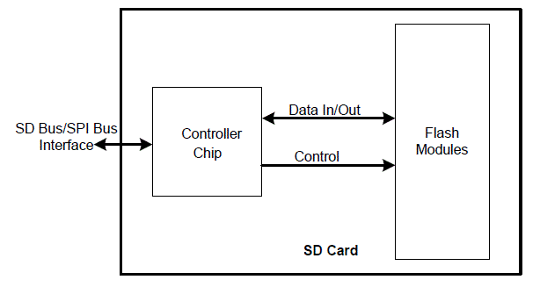
Fig 1 Functional Block Diagram of SD Memory Card.

The capacity of the ‘memory core’ is referred to as the size of the SD card. Other than the ‘memory core’ there are certain registers associated with the ‘SD card controller’. These registers store the status of the SD card. The contents of these registers are read only. The SD card can be interfaced with the FPGA using serial data bus. It can connect using ‘SD buses’ or ‘SPI bus’. The ‘SD bus’ is designed for high speed whereas the SPI bus can operate with much lower speed only. The FPGA can read or write data the memory core and read the registers using standard SD commands send through these serial buses.

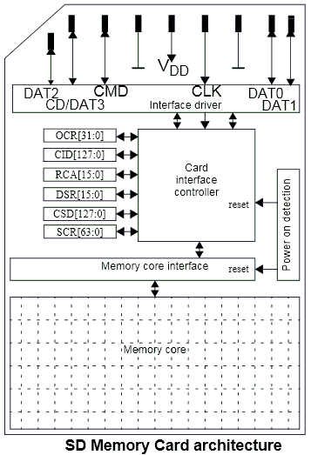
Fig. 2: Memory Architecture of SD Card

3.2. MODE OF TRANSMISSION
SD cards can transmit in one of three ways: the serial peripheral interface (SPI), which uses a different parallel input and output from 1-bit SD cards, as well as 1-bit SD cards' one-time transfer type and different command and data channels, and 4-bit SD modes, which use a wider parallel transmission bus and have additional pins and some reset pins. SD card mode provides faster and more reliable access. In 1-bit SD mode, the maximum transfer rate is 25 Mbps, whereas in 4-bit SD mode, the maximum transfer rate is 100 Mbps. Even if the data transfer rate is higher in 4-bit SD transfer mode, the system's complicated structure and timing make it challenging to build.

3.3 BUS PROTOCOL OF SD CARD
The idea behind SD communication is straightforward; it operates in a master-slave fashion. A master controller and many slave controllers connected through 3-6s lines are usual in such a setup. They are labelled as "CMD," "CLK," and "DAT0-3" (data lines).

Table 1. Pin functions of SD mode.
Name | Functions
CLK | microcontroller uses this pin to send clock signal to SD card.
CMD | bidirectional pin for information and command transmission between microcontroller and SD card.
DAT0-3 | Four bidirectional pins are used for bulk data transfer data between microcontroller and SD card.

3.4 SYSTEM FILE OF SD CARD
On the SD card, a FAT16 file is divided up into four portions. File Data Table (FDT), File Allocation Table (FAT), and Partition Boot Record (PBR) are the three tables that make up the File System (File Directory Table). The BPB (BIOS Parameter Record Blocks), the hard drive flag record book, the partition boot record code section, and the end Flag 55AA are the standard components of partitioned boot files.

3.5 SD CARD COMMANDS
SD internal memory requires a total of six bytes to execute an instruction. This consists of the one-byte command code, four bytes of command inputs, and the checksum bits. When transferring SD card instructions, the host system must always give 4 bytes of argument data, regardless of whether any parameters are included in the command. In this case, the SD card will just ignore the supplied value. Below Table 2. describes the commands of SD card and the functions of each command of the SD card.

Table 2. Commands of SD card for SPI mode
Commands | Functions
CMD 0 | Software gets reset.
CMD 1 | Initialization starts.
CMD 3 | Request card send back the RCA address.
CMD 7 | Card entering the state.
CMD 9 | Read CSD registers.
CMD 10 | Read CID registers.
CMD 12 | Stop reading data
CMD 16 | Change of size in read/write.
CMD 17 | Read command for single command.
CMD 18 | Read command for multiple commands.
CMD 23 | Amount of block sent.
CMD 24 | Write in for single block.
CMD 25 | Write in for multiple blocks.
CMD 32 | Start erase block.
CMD 38 | Erase the command.
CMD 55 | ACMD <n> leading command.
CMD 58 | Read OCR.

CHAPTER 4
FPGA

4.1 FPGA PRINCIPLE
Field Programmable Gate Arrays (FPGAs) are semiconductor devices that are based around a matrix of configurable logic blocks (CLBs) connected via programmable interconnects. FPGAs can be reprogrammed to desired application or functionality requirements after manufacturing. This feature distinguishes FPGAs from Application Specific Integrated Circuits (ASICs), which are custom manufactured for specific design tasks. Although one-time programmable (OTP) FPGAs are available, the dominant types are SRAM based which can be reprogrammed as the design evolves.

The process of transforming the original system concept into an actual FPGA implementation that performs the required task is called functional design. A device built as an array of configurable logic elements (LE). Each logic elements can be configured to work in combination or sequential functions. Modern FPGAs integrate other useful things features such as built-in multipliers and high-speed (I/O), data converters including analog to digital converters, large RAM arrays (random access memory), and processor. All these features allow you to create complex system-on-Chip (SoC) hardware that provides options such as create a specific custom Central Processing Unit (CPU), the purpose of which is executing multiple statements.

An existing printed circuit board (PCB) such as B. DE10 System on Chip (SoC) and allows you to build and craft using the Hard Processor System (HPS) implements two embedded systems in real time, each working independently or together with its own processor (CPU). MIMAS V2 is a feature-rich and cost-effective FPGA development board powered by Xilinx Spartan-6 FPGA. MIMAS V2 is specifically designed for experimenting and learning system design using FPGAs. This development board features a SPARTAN XC6SLX9 CSG324 FPGA with 512MB DDR SDRAM. A USB 2.0 interface allows quick and easy configuration downloads to the integrated SPI flash. You don't need to buy expensive programmers or special downloader cables to download bitstreams to your board. Fig1. displays the FPGA development board.

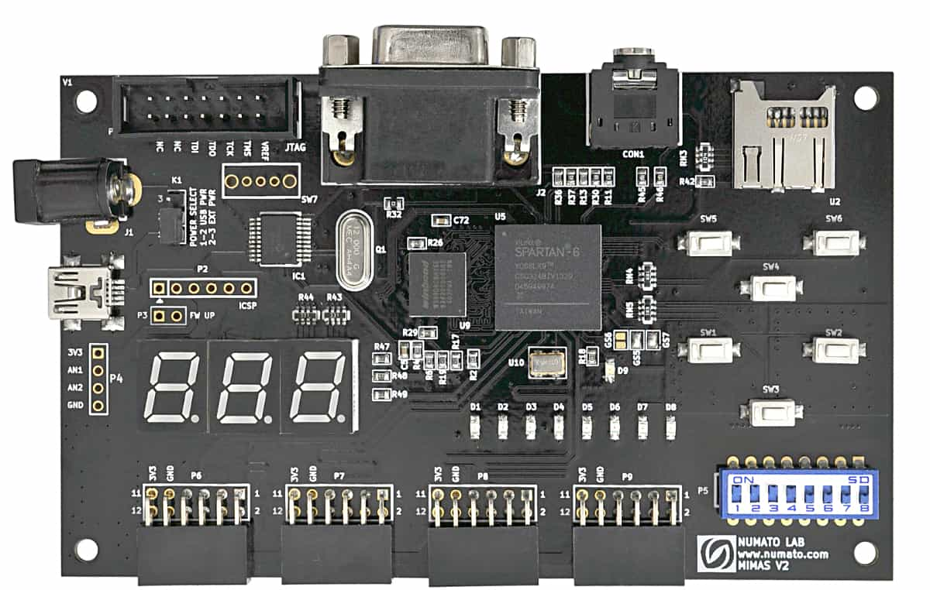
Fig. 3 FPGA Development Board

4.2 FEATURES OF FPGA
- FPGA: Spartan XC6SLX9 in CSG324 package.
- DDR Memory: 166MHz 512Mb LPDDR (MT46H32M16LF/W949D6CBHX6E).
- Flash memory: 16 Mb SPI flash memory (M25P16).
- USB 2.0 interface for On-board flash programming.
- FPGA configuration via JTAG and USB 8 LEDs, six push buttons and 8-way DIP switch for user-defined purposes.
- VGA connector, Stereo Jack.
- Micro SD card adapter.
- Three-digit seven segment displays.
- 32 IOs for user-defined purposes.
- Four 6×2 expansion connectors.
- Onboard voltage regulators for single power rail operation.

CHAPTER 5
SPI
5.1 WORKING OF SPI
The Serial Peripheral Interface (SPI) is a protocol utilized by many electrical devices. A card reader for SD or RFID cards and a wireless 2.4 GHz transceiver are examples of peripherals that utilize SPI to connect with a microcontroller. Sending and receiving any number of bits is possible so long as the flow is continuous. I2C and UART both transmit data in discrete packets with a defined number of bits. Start and stop criteria, which indicate the beginning and end of each packet, distort data transmission.
Master-slave is the relationship between SPI devices. The device in control is known as the master, while its subordinates (often sensors, displays, or RAM) are referred to as slaves. A straightforward SPI network consists of a single master and a single slave however a single master may supervise several slaves. Fig. 1 depicts the connection between the master and the slave.
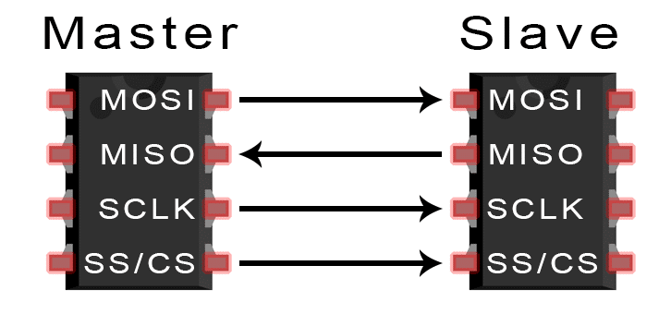
Fig 4 MOSI

5.2 SERIAL VS PARALLEL COMMUNICATION
Electronic devices sending bits of data through wires physically connected between devices. A bit is like a letter in a word, except instead of the 26 letters (in the English alphabet), a bit is binary and can only be a 1 or 0. Bits are transferred from one device to another by quick changes in voltage. In a system operating at 5 V, a 0 bit is communicated as a short pulse of 0 V, and a 1 bit is communicated by a short pulse of 5 V.
The bits of data can be transmitted either in parallel or serial form. In parallel communication, the bits of data are sent all at the same time, each through a separate wire. The following diagram shows the parallel transmission of the letter “C” in binary (01000011):
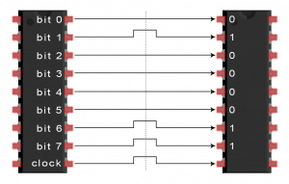
Fig 5 Bit Transmission in Parallel Communication
In serial communication, the bits are sent one by one through a single wire. The following diagram shows the serial transmission of the letter “C” in binary (01000011):
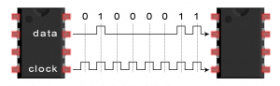
Fig 6 Bit Transmission in Serial Communication

5.3 PIN FUNCTIONS OF SPI
- Master Output/Slave Input (MOSI) - the master transmits data to the slave.
- Master Input/ Slave Output (MISO) – slave delivers data to master,
- Clock (SCLK) – clock signal line.
- Slave Select/Chip Select (SS/CS) – allows the master to select to which slave to transfer data.

5.4 MISO and MOSI
The master sends individual data bits to the slave over the MOSI connection. The master transmits data to the slave using the MOSI pin. The norm for data transmission between the master and the slave is most significant bit first. The slave sends the least significant piece of data back to the master.

5.5 SPI DATA TRANSMISSION
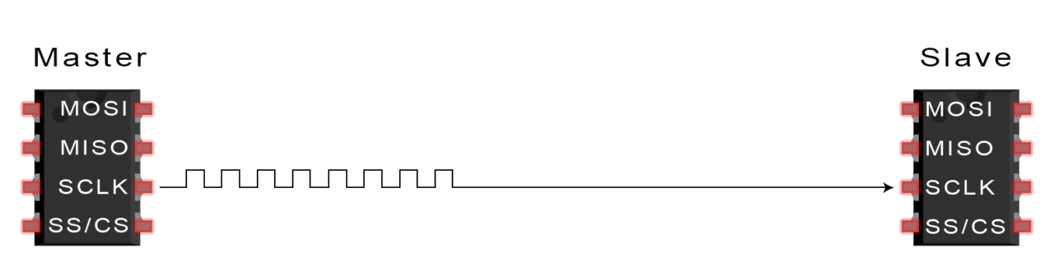
Fig 7 Clock Signal
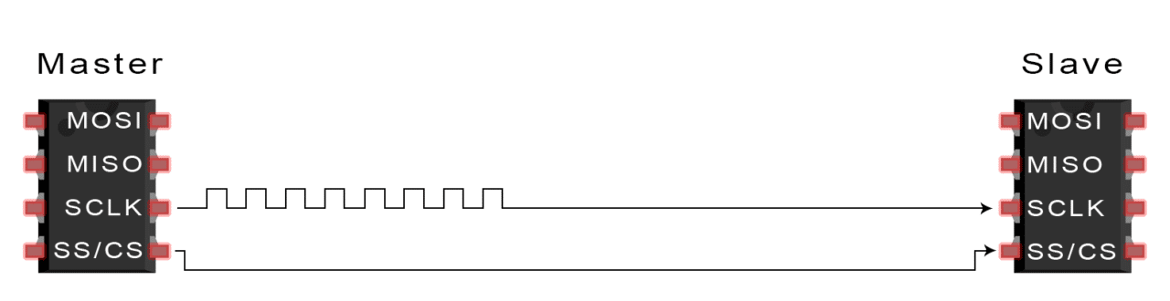

Fig 8 Slave Select Activation
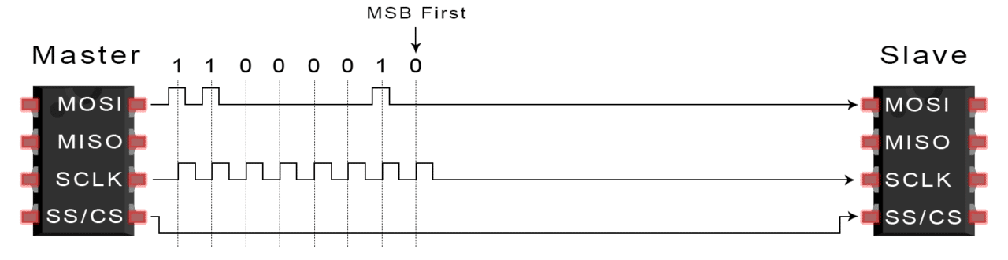 Fig 9 Master to Slave Data Transfer
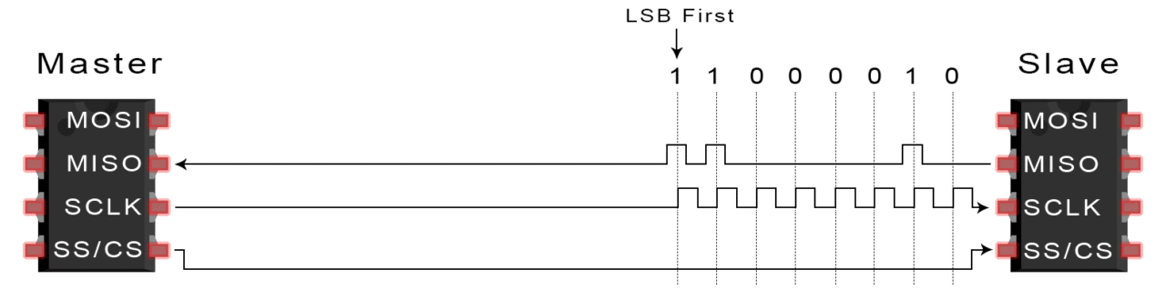
Fig 10 Slave to Master Data Transfer
The master generates the frequency of the clock. When the master pushes the SS/CS pins to a reduced voltage state, the slave is activated. The master transmits information bit by bit to the slave over the MOSI line. The slave inspected each received bit. When a response is required, the slave sends the data back to the master bit-by-bit over her MISO line. The master performs an analysis on the received bits.

5.6 ADVANTAGES
Since there is no beginning or end, information may be sent without interruption. The I2C bus does not require a sophisticated method of addressing that is slave-specific. The rate of data transfer is more rapid than I2C. By separating the MISO and MOSI channels, data transmission and reception may be performed concurrently.

CHAPTER 6
WORKING SYSTEM
6.1 REQUIREMENTS
6.1.1 SOFTWARE REQUIRMENT
- Xilinx ISE 14.7
6.1.2 HARDWARE REQUIRMENTS

- FPGA
- SD CARD
- SPI
- FAT32

6.2 TYPES OF SD MODES
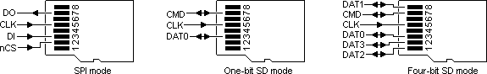
Fig 11 SPI mode pin diagram
Fig 12 One-bit SDsmode pin diagram
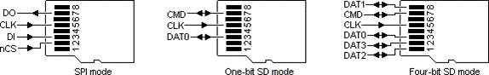
Fig 13 Four-bit SD mode pin diagram

Among these three modes from Fig 2, Fig 3, Fig 4 (SPI mode, one-bit SD mode and four-bit SD mode), the latter two are significantly slower than the former. The higher bit rate of four-bit SD mode allows for rapid and efficient command execution, including read/write operations.

Table 3 Comparison of one-bit SD mode, four-bit SD mode, SPI mode.

 | One - bit SD mode | Four - bit SD mode | SPI mode
Input Signal | 1 CLK PIN,  1 DATA PIN | 1 CLK PIN,  1 CMD PIN,  4 DATA PINS | MOSI,  MISO, CS, CLK
Minimum Frequency | 0 MHz | 0 MHz | 1 kHz
Maximum Frequency | 25 MHz | 25 MHz | 75 MHz
Bit Rate | 25 Mbps | 100 Mbps | 25 Mbps

6.3 CONTROL STRUCTURE OF FPGA
Fig. 5 illustrates the recommended FPGA block architecture for 4-bit SD mode. Regarding the data pins, 4-bit SD mode requires only one clock and four data ones. The Clock Control module's principal purpose is information sharing. All functionality of 4-bit SD mode may be assured with the Command Control package. Due to the SD card's limited 512-byte memory location, two FIFO buffers are designed to temporarily store data during transmission and reception.

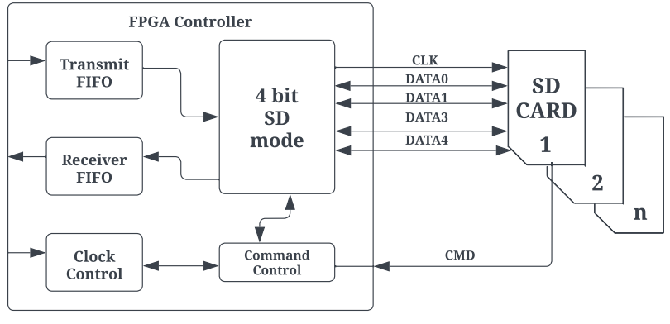
Fig 14 FPGA block diagram for 4-bit SD mode.

6.4 SD CARD INITIALIZATION
To start an SD card increased actions are required. A switch on the rear of every SD card slot indicates whenever a card is inserted. We must enter the card choose pin. It will disable the card. SD must always be initialized with a minimum 76 - 160 pulses transmitted to the clock. SD lacks an internal clock primary source.

Command 0 is just a computer reset which puts the SD card to rest. When it reaches this condition, it may be configured to operate in SPI mode. There is only one NCR needed.
cmd_out<= 56'hFF_40_00_00_00_00_95
Command 8 is to check if we are using the correct card. Otherwise, this particular program will always return to the beginning. This part of the initialization procedure is mandatory.
cmd_out<= 56'hFF_48_00_00_01_AA_87;
Then to get R3 reaction after the R1 reaction. The one and only thing we need to understand is that the final byte we get has to be (hex) AA. This signals the detection of an SD card version 2 (SDHC). There is only one NCR necessary. Furthermore, the ACMD41 instruction configures the SD card to operate in SPI mode. There is only one NCR necessary.
cmd_out<= 56'hFF_69_40_00_00_00_01;
During the initial run, the idle flag remains set. This activation procedure is complete if the flag is cleared. Alternatively, command 55 is delivered. The ACMD command has a feature in that all commands are preceded with command 55.
cmd_out<= 56'hFF_77_00_00_00_00_65;
CRC, NCR, and null arguments are often transmitted as 0xFF. The SD card operates in this manner, which explains why the data remains high. Whenever the SD card gets busy, the output data pin goes to ground, and when it is ready, it goes too high. This is helpful when writing on cards. To read a state register, no instructions are required. Fig. 6 illustrates the initialization of Secure Digital card.
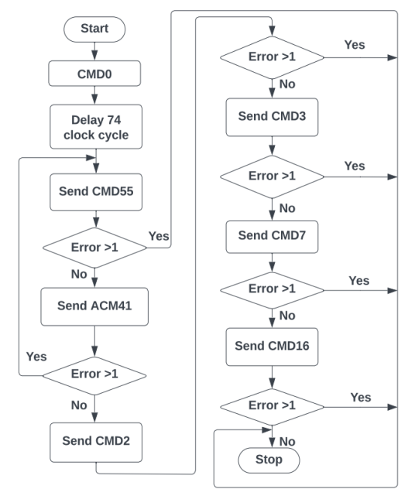
Fig 15 SD card initialization flow chart.

6.5 WRITE DATA FOR SD CARD
The data could well be transferred to the SD card's 'Memory Core' using the instructions shown below, followed by real data. WRITE_BLOCKs–Single blocks of data is being written (512 bytes).
WRITE_BLOCK
A block on an SD card has been believed to be a sequence of 512 bytes of memory addresses for as long as anybody can remember. The WRITE BLOCK command is used to permanently store data in a memory block beginning at address 2000. For the command set to operate properly, it must appear as follows:

Everything begins at byte 0x18 (command). Second through fifth bytes (0x000007d0) (argument) (This option is needed to be 0, even when the other commands have no further arguments. (CRC) represents the random values included in the sixth byte. Seven-byte NCR. After receiving the command from the FPGA, the R1 should respond. Every bit must be zero. With the R1 response byte set to zero, the FPGA is able to transmit the data for writing to the SD card. The minimal data length should be 512 bytes. This is true even if the length of the real data is shorter. Immediately following the 512 bytes of data is the Data Token byte. Next, a 16-bit CRC byte must be utilized for the final verification. The total number of bytes in the data packet will be 515, which is equivalent to 1 plus 512 plus 2. The least significant bit (LSB) is set to 1 in this informative token (0xFE).

The command to be concerned with is 24, and until a clear R1 data is received, dummy bytes are sent; a dummy byte is followed by a token byte (11111110b); the same 512 bytes of data are sent; two CRCs are sent to determine if the data is valid; and finally, a data response is received to determine if the data is viable. This is accomplished in hardware, not via an SD card erase command.
cmd_out<= {16'FF_58, address, 8’FF};

After receiving the data response, the SD card may be written to; however, before the card's status can be verified, it must be de-asserted eight times (1 byte) and then reasserted. While the preceding code snippet may occasionally function and is frequently how datasheets are to be understood, the SD card must be deselected prior to beginning the writing procedure. When the SD card is being used for something else, the output data will be reduced (if this option is set), but when it is no longer in use, the output data will be increased to indicate that it is accessible. Fig. 7 illustrates write data of Secure Digital Card.
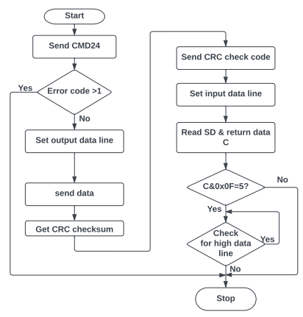
Fig 16 Write data flow chart for SD card.

6.6 READ DATA FOR SD CARD
We can retrieve the information saved in the "Memory Core" of SD card by following the instructions listed below.
A single block of data (512 bytes) is read from the SD card in READ BLOCK mode.
READ_SINGLE_BLOCK
Each SD card block is represented by a 512-byte memory address sequence. The READ SINGLE BLOCK command is used to get a single block of data beginning at the given memory address. In this instance, 2000 is the beginning address. The command packet format must be as follows:
When the time comes to record the succeeding data block.
0x51 is the value of the first byte (command).
(The argument) positions 0x000007d0 through 0x000007ff (This field must be set to zero even when there are no parameters for those other commands.) (CRC) represents the random values included in the sixth byte. Seven-byte NCR. The response from R1 should reach FPGA immediately following the instruction. All bits should be set to zero. The FPGA may get information from the SD card if the R1 response byte is zero. Each READ SINGLE BLOCK request from an SD card returns 512 bytes in response. Fig. 9 illustrates read data of Secure Digital Card.
cmd_out<= {16h’FF_51, address,8’hFF};
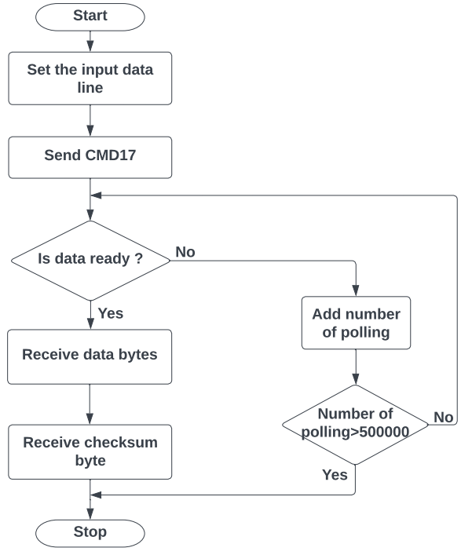
Fig 17 Read data flow chart for SD card.
6.7 SD CARD CONTROLLER WORKING
Input
Clock - 25Mhz
Reset - Active high reset
Din [7:0] - Data in [write operation]
Address [31:0] - Sector address [Read/Write operation]
Wr - Write enable
Rd - Read enable
Multi_sector_en - Multiple sectors read Henable
I_blk_num - Read total number of blocks in multi sector mode
Miso - Read total number

Output
Cs - chip select
Mosi - FPGA send command/data to be shared
Sclk - spi clock
byte_counter - byte count till 512 bytes
Dout, recv_data - data out from Sd card
status - state changes
byte_available - ensure the valid data by data enable
Reading - data is reading from Sd card
Ready - ready to send the read/write command
Read_for_next_byte - each byte has 8bits. Ready to send next byte
Read_done - enable every 512 bytes completed

6.8 FILE FORMAT of FAT32
Data is read from and written to memory modules using FAT32. Initially, clusters concentrate on a small number of sectors. It is displayed in Fig. 9.
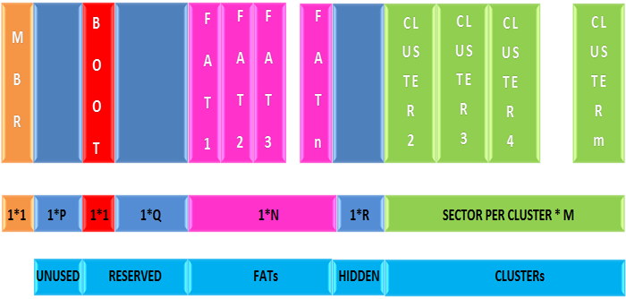
Fig 18 Format of FAT32.

The first and foremost sector is the MBR which is known as Master Boot Record. This comes after a lengthy time in which many sectors remained inactive. These sectors are designated as reserved ones; the BOOT sector comes first, followed by the FAT sector. The count of FAT sectors is determined by the file system size. Clusters followed FAT sectors and before insecure ones.

6.9 READING FILE FROM FAT32
Fig. 10 illustrates that it is able to read FAT32-formatted files. This sector read has been discovered to be the final phase of every operation. We can use the READ_SINGLE_BLOCK command supplied by the SD Command Layer to read only this one sector from the memory core of the SD card.
sdcard_fat _32_read. V
From Fig. 10FAT32 sector cluster counts are expressed by 32 bits. Every cluster is represented by a 32-bit set. If each cluster consists of 512 bytes, then the sector will have 128 cluster pointers. This section describes how space is allotted to files in a FAT32 file system.

The following equation may be used to compute the number of the next cluster pointer within the FAT32.
Number of sectors of FAT in the next cluster pointer = number of first sectors in partition + reserved number of sectors + ((clusters of current number * 4)/bytes per sector).
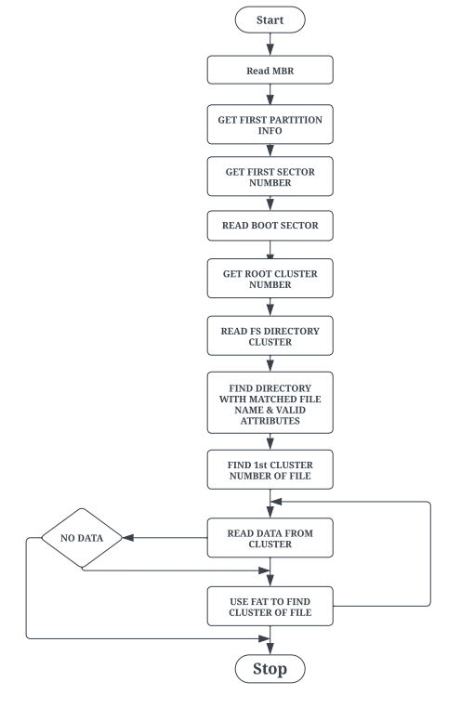
Fig 19 FAT32 Algorithm for reading.

From Fig. 11 the yellow-coloured box indicates the cluster that contain the data for each file in FAT32 and the respective cluster pointers. The red-coloured line shows that the next cluster pointer which matches the present cluster is being sought, while the green-coloured line shows that the next cluster is being sought using the cluster thing about having in the FAT32 clusters pointer.
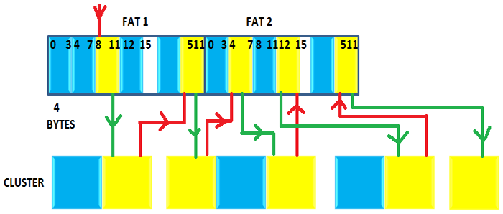
Fig 20 Read Scrambler file in flash ‘Memory Core’.

CHAPTER 7
RESULTS

Table 4 Comparison between existing methods and our method
Proposed Work | LUT (Look-Up Table) | Flip Flop | Clock period
Spartan 6 | 916 | 464 | 5.35 ns
Artix-7 | 653 | 413 | 3.254 ns
Existing Method
[1] Artix-7 | 1025 | 579 | 10.5 ns

Comparing the specifications of the Spartan 6 FPGA (530 Slice Registers, 916 LUT's, 464 Flip Flops, 5.35 ns clock period, 186.925 MHz frequency) and the Artix-7 (512 Slice Registers, 653, LUT's, 413 Flip Flops, 3.254 ns clock period, 307.342 MHz frequency) demonstrates that our proposed results provide better resource utilization than existing methods.

CHAPTER 8
CONCLUSION

Thus, we conclude our proposed work that an FPGA controller allows SD card writing and reading with Strontium 4-bit SD mode using Spartan 6 FPGA and Artix-7 which was executed in Xilinx ISE software tool. Easily expandable storage system add number SD cards contain sharing the same clock and data signals different chip select signal for each card was suggested the architecture involves accessing each card in sequence, but it is allowed.

8.1 FUTURE SCOPE
- For future work, in the implementation of FPGA-based classification systems, it is proposed to change the SD memory for a Double Data Rate 3 Synchronous Dynamic Random-Access (DDR3-SDRAM) memory, and test with different configuration to reduce the access time; in the algorithmic part it is proposed to reduce the extraction time of the characteristics using time-frequency characteristics.

CHAPTER 9
REFERENCE

[1] D. C. Costache, L. A. Perişoară and A. Florescu, "FPGA Implementation of a SD Card Controller using SPI communication," 2020 12th International Conference on Electronics, Computers and Artificial Intelligence (ECAI), 2020, pp. 1-4.
[2] Zhenlin LU, Jingjiao LI, Yao Zhang. 2010. The Reading/Writing SD Card System Based on FPGA. 2010 First International Conference on Pervasive Computing Signal Processing and Applications (PCSPA), pp. 419-422.
[3] O. Elkeelany and V. S. Todakar, "Data Archival to SD Card Via Hardware Description Language," in IEEE Embedded Systems Letters, vol. 3, no. 4, pp. 105-108, Dec. 2011.
[4] Gul Munir Ujjan, Abdul Malik, Mohd Zaid Abdullah, Shakil Ahmed, “Implementation of 4-bit data transmission for accessing SD card with FPGA Embedded Soft Processor;” ICIIT '19, February 20–23, 2019, DaNang, Viet Nam.
[5] Jiayi Qiang, Yong Gu and Guochu Chen, “FPGA Implementation of SPI Bus Communication Based on State Machine Method,” Journal of Physics: Conference Series 1449 012027, 2020.
[6] Pallavi Polsani, V. Priyanka.B, Y. Padma Sai, “Design & Verification of Serial Peripheral Interface (SPI) Protocol,” IJRTE, Volume-8 Issue-6, March 2020.
[7] Fareha Naqvi, “Design and Implementation of Serial Peripheral Interface Protocol Using Verilog HDL,” International Journal of Engineering Development and Research 2015.
[8] N Nandhagopal, S Navaneethan, V Nivedita, A Parimala, D Valluru “Human Eye Pupil Detection System for Different IRIS Images” Journal of Computational and Theoretical Nanoscience volume 18, issue no 4, page no 1239-1242, 2021.

[9] Manish Kumar Birla. 2006. FPGA Based Reconfigurable Platform for Complex Image Processing. IEEE, 6th International Conference on EIT, pp.204-209.
[10] V. Asanza, A. Constantine, S. Valarezo and E. Peláez, "Implementation of a Classification System of EEG Signals Based on FPGA," 2020 Seventh International Conference on eDemocracy & eGovernment (ICEDEG), 2020, pp. 87-92.
[11] S Navaneethan, N Nandhagopal, V Nivedita “An FPGA-based real-time human eye pupil detection system using E2V smart camera”, Journal of Computational and Theoretical Nanoscience 16 (2), 649-654 2019.
[12] Navaneethan S, Nandhagopal N “RE-PUPIL: resource efficient pupil detection system using the technique of average black pixel density” Sadhana vol.46 issue no. 3 2021, Springer India
[13] N Nandhagopal, S Navaneethan, V Nivedita, A Parimala, D Valluru “Human Eye Pupil Detection System for Different IRIS Database Images” Journal of Computational and Theoretical Nanoscience volume 18, issue no 4, page no 1239-1242, 2021.
[14] Yansi Yang, Yingyun Yang, Lipi Niu, Huabing Wang and Bo Liu, "Hardware system design of SD card reader and image processor on FPGA," 2011 IEEE International Conference on Information and Automation, 2011, pp. 577-580.
[15] M. K. Birla, "FPGA Based Reconfigurable Platform for Complex Image Processing," 2006 IEEE International Conference on Electro/Information Technology, 2006, pp. 204-209.

